<https://www.udemy.com/course/the-complete-web-development-bootcamp/learn/lecture/12371166#questions/12105158>

The unix command line

Shell analogy

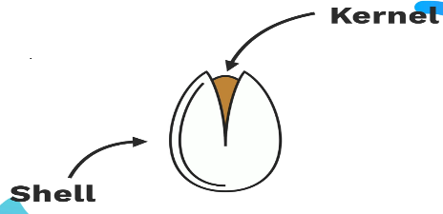

The Kernel is the operating system that interfaces with the hardware

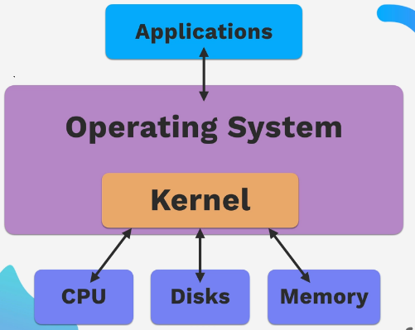

The shell is the user interface that allows humans to interact with the operating system and thus the hardware.

The shell can be a GUI or the command line CLI

CLI interfaces with the kernel

BASH shell - CLI for unix or unix like systems



Using command line gives programmer more control

Directory navigation - ls , cd , cd~

Restart here

<https://www.udemy.com/course/the-complete-web-development-bootcamp/learn/lecture/12384360#questions/12105158>